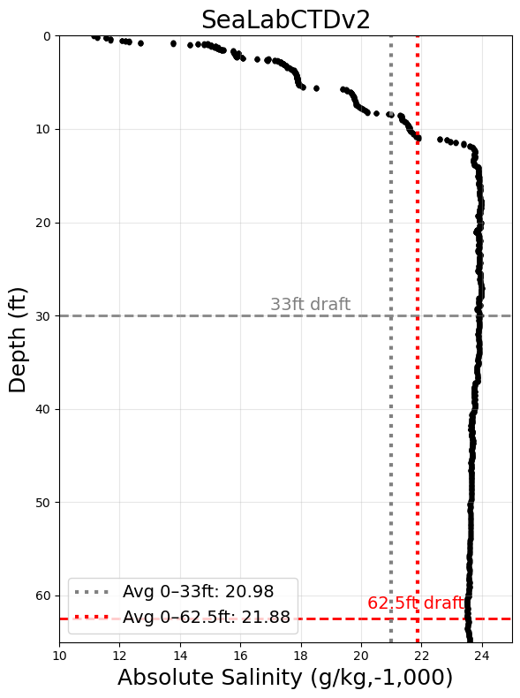

**Test Date and Time**

28 MAY 2025, 1214 – 1225 (ZD+8)

**Avg Sampling Frequency**

4.98 Hz

**Location**

Valdez Marine Terminal Berth 5

**CTD Cast Location on Vessel**

Ship starboard side to berth. CTD cast from port side on maindeck astern of the FRB

**Tide:** +6.5ft

**Average salinity 0-33ft:** 1021.0

**Average salinity 0-62.5ft:** 1021.9

**Difference:** 0.9

**Surface salinity:** 1011.1

**Salinity at 62.5ft:** 1023.9

**Difference:** 12.8

**Qualitative Assessment of Weather**

Cloudy and clear, no rain

